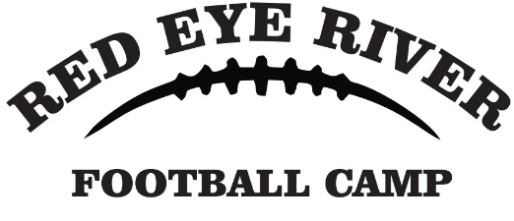
We are excited to reach out to you with an incredible opportunity!
We are hosting our 4th annual youth football camp from July 17th to 19th in Menahga and Sebeka. This camp brings together children in grades K-6 from across Minnesota, offering them the chance to develop self-esteem, engage in physical activity, and learn the basics of football. This year, we are thrilled to have KJ Osborn, current Minnesota Vikings wide receiver, as our celebrity coach.
To ensure that every child can participate, we rely on the support of local businesses like yours. We kindly request a $200 contribution, which will go directly towards providing jerseys for the children, snacks, and securing the appearance of our celebrity coach. We rely entirely on volunteers and donations, and 100% of the money received goes directly into the camp.
Your partnership will make a tangible impact on the lives of these young athletes. It will help create a sense of unity and pride as each child receives their own camp jersey. Your donation will also help grow football in our area, as we have kids signed up from Bertha, Hewitt, Clarissa, Eagle Bend, Wadena, Perham, Frazee, Park Rapids, Nevis, Menahga, Sebeka, Verndale and more. Additionally, your support will enable us to accommodate the growing demand, as we anticipate around 200 participants this year.
We genuinely appreciate your consideration of this partnership opportunity. By joining together, we can make a lasting difference for these children and demonstrate your commitment to our community. If you have any questions or need further information, please feel free to reach out to us.
Thank you for your time and ongoing support. We look forward to the possibility of collaborating with you and making this year's youth football camp a resounding success.
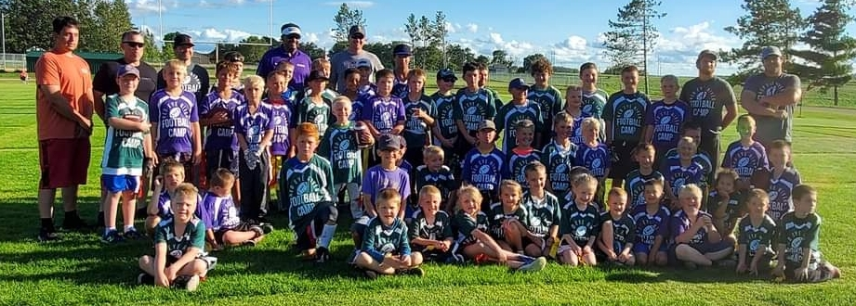
Warm regards,
Kim Rife
Redeye River Football Coordinator
740-304-2996
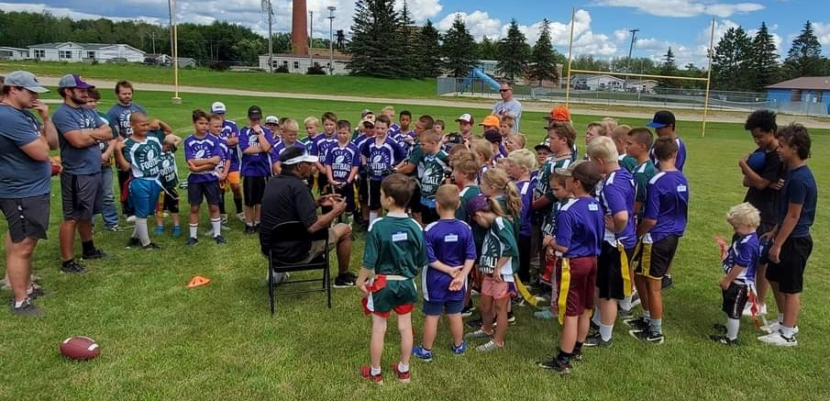
rifesllc@hotmail.com
Checks need to be mailed by July 10th to:
Redeye River Football
PO Box 111
Park Rapids, MN 56470

